Infrared Alert System with RF Capability
System Desing and Modeling
Version 2.0
12/13/2013

Max Cope
LesliE Eide
Chris Klupenger

TABLE OF CONTENTS
1 Level Block Diagram IR sensor Alert System RF Capability 3
1.1 Level Block - 0 3
1.2 Level Block - 1 4
2 Level Block Diagram of Subsystems 5
2.1 Level Block – 0 RF Subsystem 5
2.2 Level Block – 0 IR Subsystem 6
2.3 Level Block – 0 Microcontroller 7
3 Two Different Views 8
3.1 Activity View 8
3.2 Interaction View 8

Level Block Diagram IR sensor Alert System RF Capability

Level Block - 0
This is the level 0 block diagram for the IR Alert System with RF Capability.

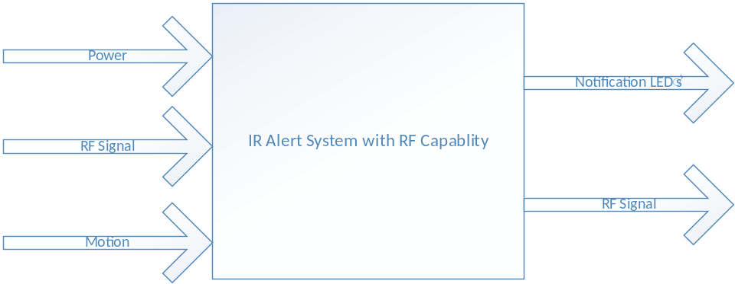
Figure 1 - Level 0 IR Alert System with RF Capability

Module | IR Alert System with RF Capability
Inputs | Power: 9V Battery  RF Signal: Incoming signal from another IR Alert System with RF Capability Modules  Motion: Motion detection from the surrounding area
Outputs | Notification LED’s: LED’s turn on based on which unit detected motion  RF Signal: Signal generated if motion from this IR Alert System was detected
Functionality | Senses motion in area around unit and sends a signal to another unit that it detected motion. Also receives and interoperates signal from another unit that detected motion and displays which unit sensed motion.

Level Block - 1
This is the level 1 block diagram for the IR Alert System with RF Capability.

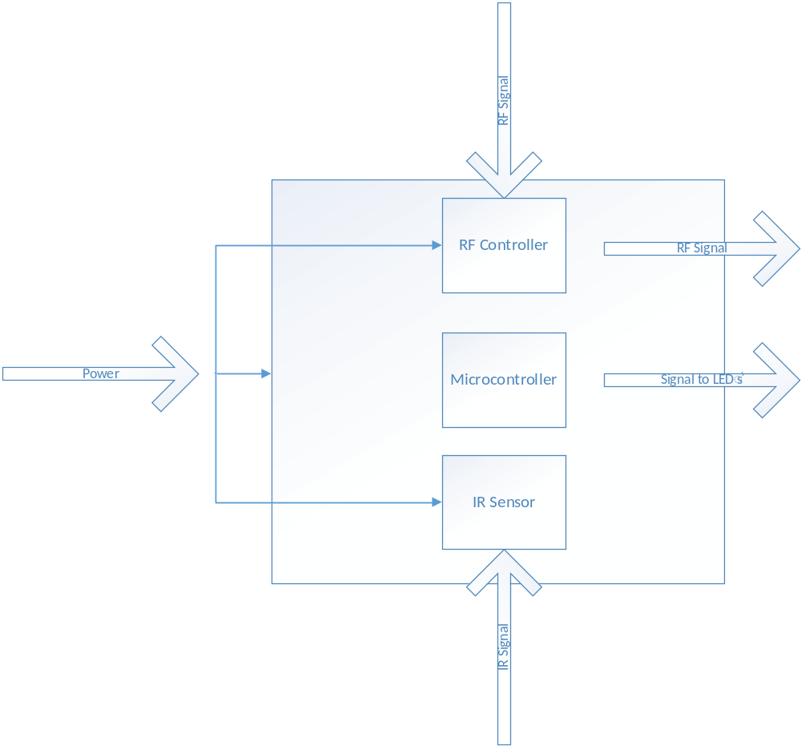
Figure 2 - Level 1 IR Alert System with RF Capability

Level Block Diagram of Subsystems

Level Block – 0 RF Subsystem
This is the level 0 block diagram for the RF Controller.
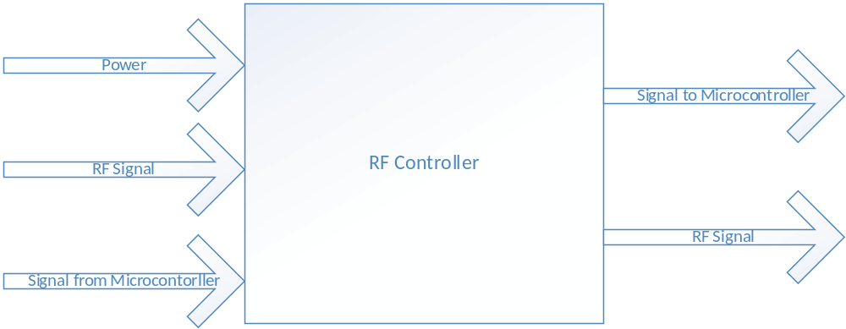
Figure 3 - Level 0 RF Controller
Module | IR Alert System with RF Capability
Inputs | Power: 9V Battery  RF Signal: Incoming signal from another IR Alert System with RF Capability Modules  Signal from Microcontroller: Microcontroller telling the RF Controller to send a signal
Outputs | Signal to Microcontroller: RF Controller telling the Microcontroller that it detected a signal  RF Signal: Sends a signal when told y Microcontroller
Functionality | Detects a RF signal that it needs to tell the Microcontroller about. Sends a signal when prompted by the Microcontroller.

Level Block – 0 IR Subsystem
This is the level 0 block diagram for the IR Sensor.
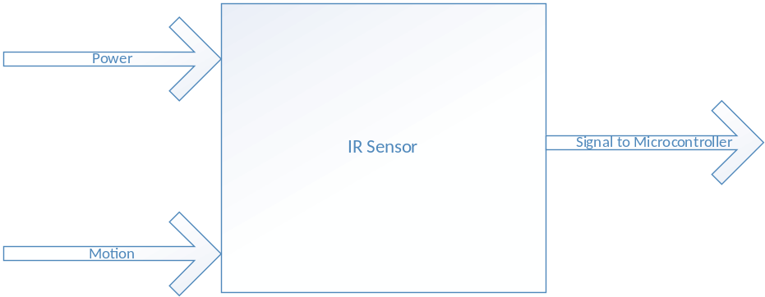
Figure 4 - Level 0 IR Sensor
Module | IR Alert System with RF Capability
Inputs | Power: 9V Battery  Motion: Motion detection from the surrounding area
Outputs | Signal to Microcontroller: Letting the Microcontroller know it detected motion
Functionality | Senses motion in area around unit and sends a signal to the microcontroller.

Level Block – 0 Microcontroller
This is the level 0 block diagram for the Microcontroller.
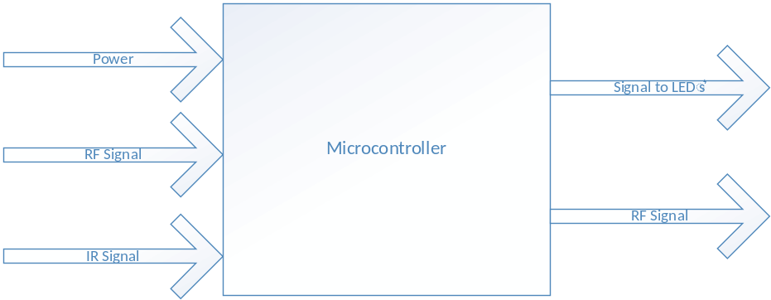
Figure 5 - Level 0 Microcontroller

Module | IR Alert System with RF Capability
Inputs | Power: 9V Battery  RF Signal: Incoming signal from another IR Alert System with RF Capability Modules  IR Signal: Incoming signal from the motion detection
Outputs | Notification LED’s: LED’s turn on based on which unit detected motion  RF Signal: Signal generated if motion from this IR Alert System was detected
Functionality | Controls the unit and the flow of the signal in the RF unit when prompted by the IR unit.

Two Different Views
This needs two different views from the six UML in lecture

Activity View
This activity view shows the two actions that trigger an LED output.

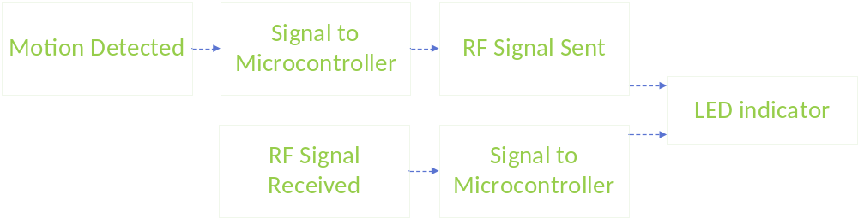Figure 6 - Activity View of a single unit

Interaction View
This is the interaction view of a single unit.
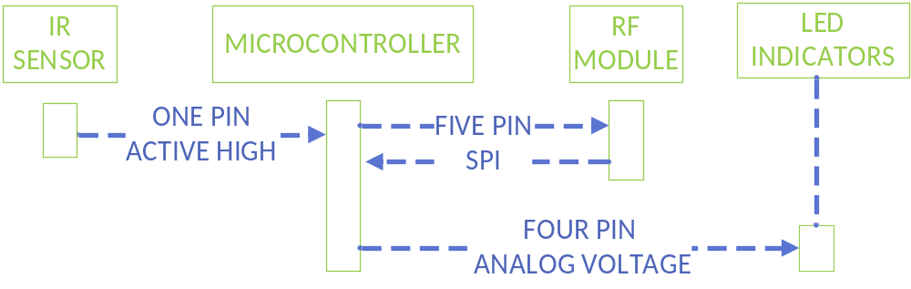Figure 7 - Interaction View of a single unit

